**Mic Box**

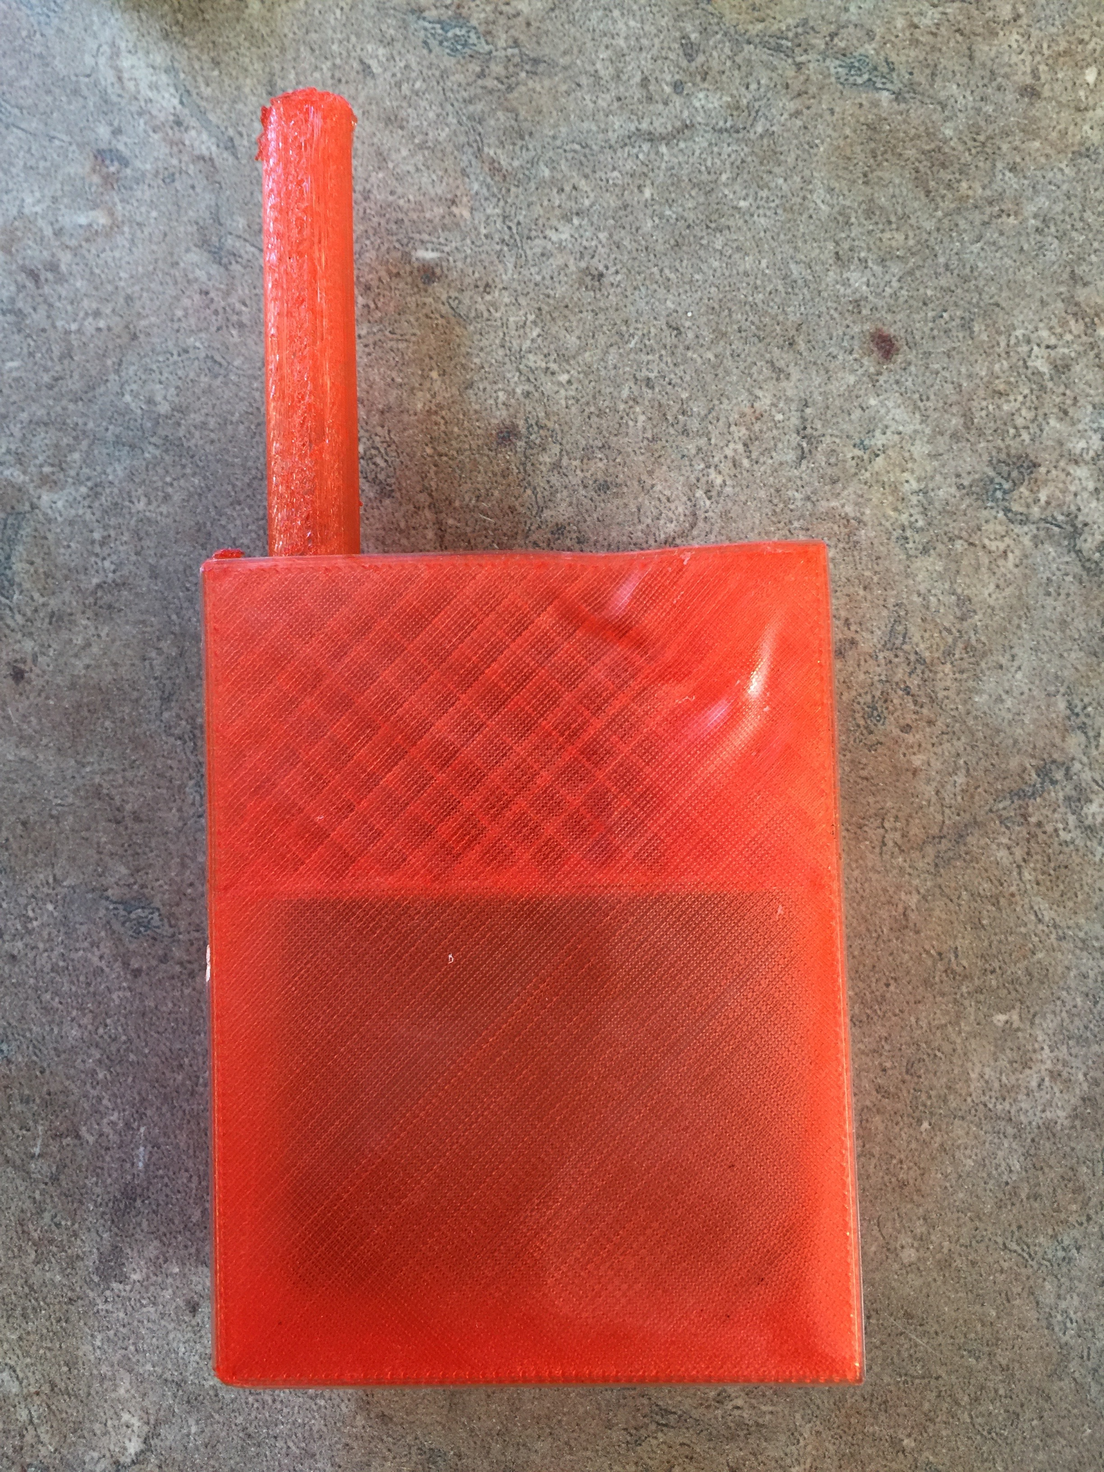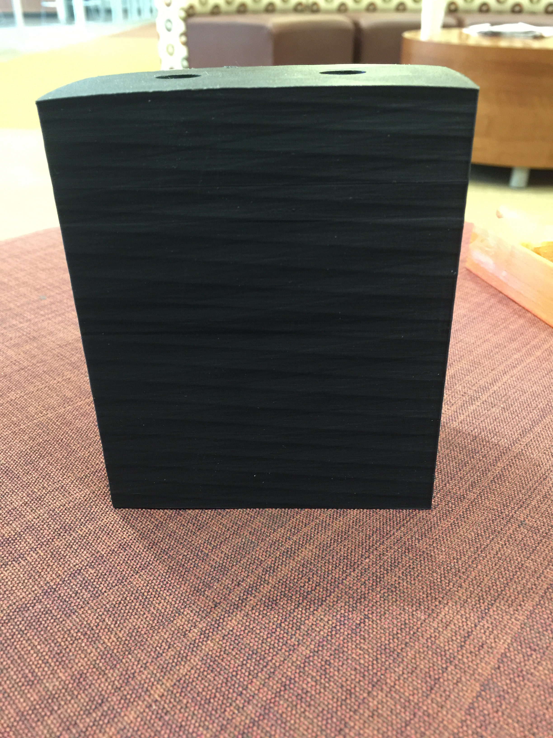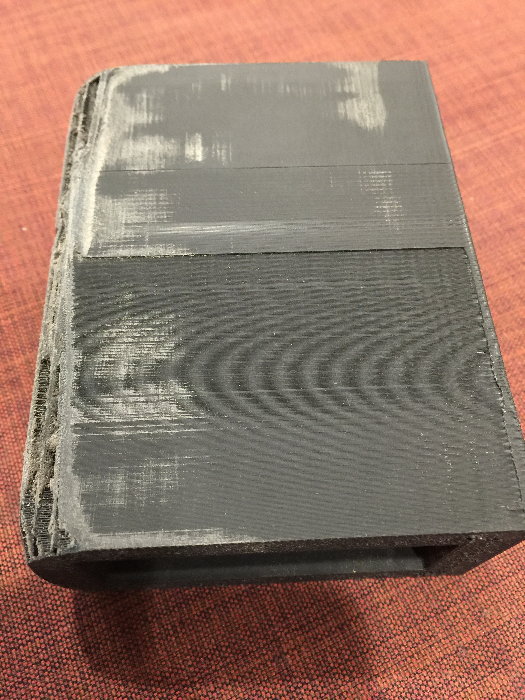

My fourth and most recent attempt ended with the case falling apart due to an error in the printer settings. The next step is to reprint this model and put it on an actor to test it out.

The first step was to create a prototype case (shown left). I created the model using a program called *AutoFusion 360*. This prototype ended up turning out differently than I expected, so we decided to use it as a model microphone. It was the same size as the one we were trying to protect. After meeting with my advisor, we decided it would be better to change the Mic Box design to a rectangle that would house the microphone body pack

My third attempt is to the left. In an attempt to get rid of the sharp edges and make it more ergonomically friendly, I attempted to sand the material. The results varied.

The model to the right is my second attempt. I made this model in an online program called *TInkercad*. This ended up being big and clunky, and we decided to cut it down by several square centimeters.

Alexander Harris

aharris44@elon.edu

https://hackaday.io/project/9858-mic-box